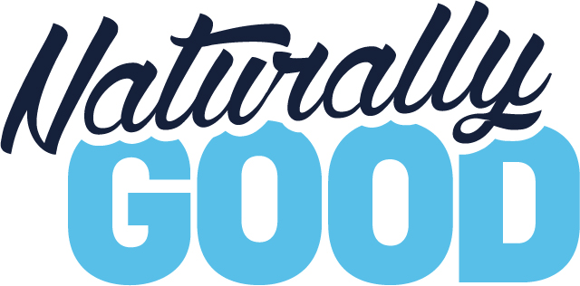

See us at Naturally Good 2019 – Australia’s largest trade exhibition for everything natural, organic and healthy!
We will be exhibiting at Naturally Good 2019, returning to Sydney for the fifth edition from 2-3 June 2019 at ICC Sydney, Darling Harbour. Become a part of this growth phenomenon, and join your consumers in their growing way of life, as they pay more attention to what they put in and on their bodies. Dedicated to the healthy retailers, brands and practitioners of the natural and organic industry, Naturally Good is THE go-to event for finding the latest products from food and beverage and beauty and personal care, to natural home and living and health.
Visit us at Naturally Good to find out about our latest products and services, and make sure you come and meet our team, try our products and see how we can you grow your knowledge and business. You might even find your next best-selling product at the show!
Register online at www.naturallygood.com.au for free entry and save the $30 door charge!

