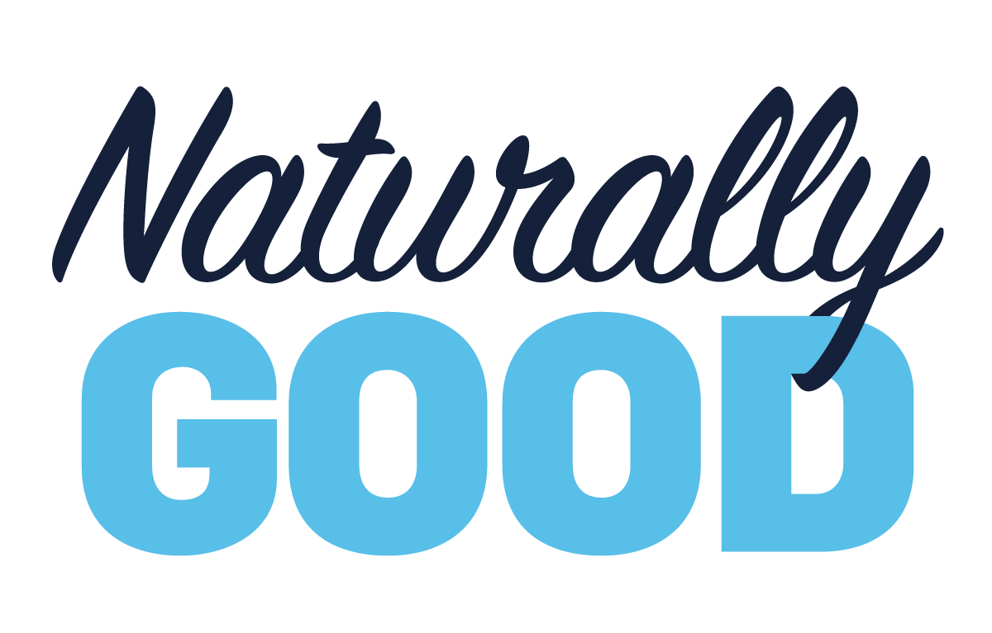
Build your profits and your business at Naturally Good 2020 – the largest trade exhibition for all things natural, organic and healthy in Australia.
Returning to Sydney for it’s sixth edition, we’ll be exhibiting at Naturally Good 2020 from 1 – 2 June 2020 at the ICC Sydney Darling Harbour. Drive higher basket values, stay competitive in the retail market, and capitalise on the growing segment of Australian consumers seeking natural and organic alternatives. Catered for your business and customers, Naturally Good is THE place to be, with the latest trends and product offerings in food, beauty, eco-living and more, from Australia’s most innovative and emerging brands, all under one roof.
Visit us at Naturally Good to find out about our products and services and see how we can help you and your business. Come meet our team and try our products, and make sure you benefit from the Natural Advantage.
Register online at www.naturallygood.com.au for free entry and save the $30 door charge!

