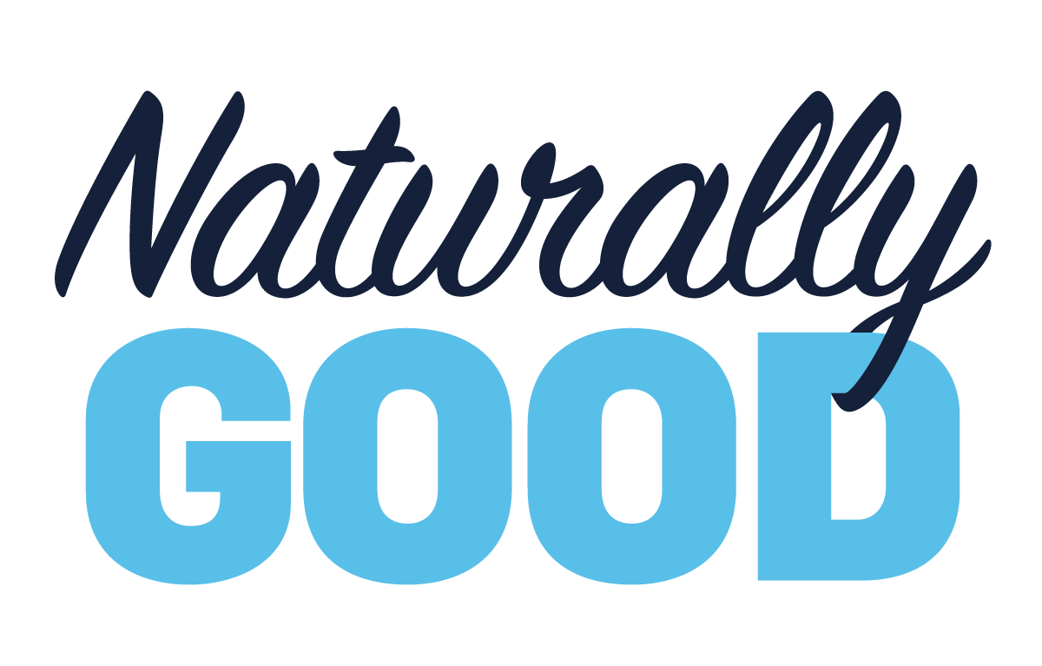
Take the natural step ahead for your business at Naturally Good 2022 – your platform for organic growth.
Returning to Sydney for its seventh edition, we will be exhibiting at Naturally Good from 6-7 June 2022 at the ICC Sydney, Darling Harbour. Drive higher basket values, stay competitive in the retail market, and capitalise on the growing segment of Australian consumers seeking natural and organic alternatives. Catered for your business and customers, Naturally Good is your unique, once-a-year opportunity to connect with like-minded producers across food, beauty, home and lifestyle in the natural and organic space.
Visit us at Naturally Good to find out more about our products and services and see how we can help you and your business.
Register online at www.naturallygood.com.au for free entry!

